Signal Quench Oil 100

Product Application:

Signal Quench Oil 100 is a premium quality, industrial grade, sheer stable, full bodied, high performance, accelerated cold quenching oil for use in large scale industrial applications.

It is formulated with select light viscosity hydro-treated neutral basestocks that prevent the retention of oil by capillary action and also reducing drag out loss blended with carefully selected premium thermally oxidative stable additive componentry, thus ensuring fuming and evaporation are kept to a minimum.

Signal Quench Oil 100 is an excellent, cutting edge, fast acting quenching oil that allows for a reduction of vapor blanket layering, enabling desired fast acting nucleate controlled boiling to occur, thus allowing for the fastest heat transfer possible.

Features and Advantages:

*High resistance to thermal cracking and decomposition
*Excellent accelerated cooling times
*Controlled quenching allowing for consistent strength and hardness, minimizing distortion

Package Size:

Drums, Pails

Typical Characteristics:

Color (ASTM) 2
Viscosity, cSt. @ 40°C 14.5
Flash Point, °F/°C 345°F / 175°C
Pour Point, °F/°C -61°F / 78°C
GMQS @ 80°F (26.7°C)
(ASTM D-3520) 6-10 seconds

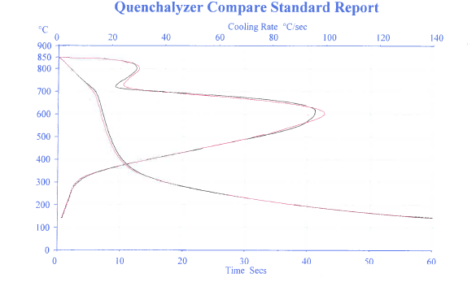
Visit us at: www.beaconlubricants.com

