Safety Data Sheet: Signal DC 860
Revision Date: January 2nd, 2022

SECTION 1 PRODUCT AND COMPANY IDENTIFICATION
PRODUCT
Product Name: Signal DC 860
Intended Use: Aluminum diecast rolling oil

COMPANY IDENTIFICATION
Supplier: Beacon Lubricants
P.O Box 754
Edinboro, PA 16412

Emergency Telephone: 1-877-734-7334 – Beacon Lubricants, Inc.
Emergency Telephone: 1-800-424-9300 (24 hours) – Chemtrec approval
Website: www.beaconlubricants.com
SECTION 2 HAZARDS IDENTIFICATION
This material is hazardous according to regulatory guidelines (M)SDS Section 15)

CLASSIFICATION:

Aspiration Hazard Cat. 1

LABEL:
Pictogram:

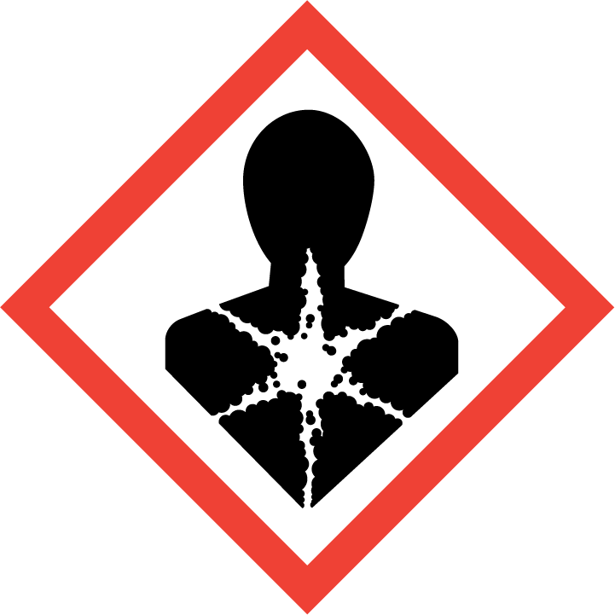

Signal Word: Danger

Hazard Statements:
H304: May be fatal if swallowed and enters airways.

Precautionary Statements:
P301 + P310: IF SWALLOWED: Immediately call a POISON CENTER or doctor/physician. P331: Do NOT induce vomiting.
Note: This material should not be used for any other purpose than the indented use in Section 1 without expert advice. Health studies have shown that chemical exposure may cause potential human health risks which may vary from person to person.
SECTION 3 COMPOSITION / INFORMATION ON INGREDIENTS
This material is defined as a mixture.
Hazardous Substance(s) or Complex Substance(s) required for disclosure
Name | CAS# | Concentration*
Distillate | 64742-46-7 | 100%

*All Concentrations are percent by weight unless material is a gas. Gas concentration are in the percent by volume.

As per paragraph (i) of 29 CFR 1910.1200, formulation is a considered a trade secret and specific chemical identity and exact percentage (concentration) of composition may have been withheld. Specific chemical identity and exact percentage composition will be provided to health professionals, employees, or designated representatives in accordance with applicable provisions of paragraph (i).

SECTION 4 FIRST AID MEASURES
INHALATION
Product is not expected to present any inhalation hazard at ambient conditions. If aerosolization and/or misting occurs and a person is over-exposed, move exposed person to fresh air. If not breathing, if breathing is irregular or if respiratory arret occurs, provide artificial respiration or oxygen by trained personnel. Loosen tight clothing such as a collar, tie, belt or waistband. Get medical attention immediately.
SKIN CONTACT
Wash contact areas with soap and water. If product is injected into or under the skin, or into any part of the body, regardless of the appearance of the wound or its size, the individual should be evaluated immediately by a physician as a surgical emergency. Even though initial symptoms form high pressure injection may be minimal or absent, early surgical treatment within the first few hours may significantly reduce the ultimate extend of injury.
EYE CONTACT
Flush thoroughly with water. If irritation occurs, get medical assistance.
INGESTION
DO NOT INDUCE VOMITTING. If conscious, rinse out mouth with water. Seek medical attention immediately.

May be fatal if swallowed and enters airways.

NOTE TO PHYSICIAN
No specific treatment. Treat symptomatically. Contact poison treatment specialist immediately if large quantities have been ingested or inhaled.
SECTION 5 FIRE FIGHTING MEASURES
EXTINGUISHING MEDIA
Appropriate Extinguishing Media: Use water fog, foam, dry chemical or carbon dioxide (CO2) to extinguish flames.
Inappropriate Extinguishing Media: Straight streams of water
FIRE FIGHTING
Fire Fighting Instructions: Fire-fighters should wear appropriate protective equipment and self-contained breathing apparatus (SCBA) with a full face piece operated in positive pressure mode.
Specific Hazards Arising from Chemical: Elevated temperatures can lead to formation of irritating fumes and vapors. Decomposing products may include the following materials: Carbon dioxide and carbon monoxide.
FLAMMABILITY PROPERTIES
Flash Point [Method]: >154°C (309°F) [ASTEM D-92]
Flammable Limits (Approximate volume % in air): LEL: N/D UEL: N/D
Autoignition Temperature: N/D
SECTION 6 ACCIDENTAL RELEASE MEASURES
Personal Precautions
Put on appropriate personal protective equipment.
Environmental Precautions
Prevent product from entering drains. Prevent entry into waterways, sewers, basements or confined areas.
Methods for containment
Stop leak if without risk
Methods for cleanup
Cover liquid spill with sand, earth, or other noncombustible absorbent material. Cover powder spill with plastic sheet or tarp to minimize spreading. Pick up and transfer to properly labeled container.
SECTION 7 HANDLING AND STORAGE
HANDLING
Eating, drinking, and smoking should be prohibited in areas where this material is handled, stored, and processed. Workers should wash hands and face before eating, drinking, and smoking. Remove contaminated clothing and protective equipment before entering eating areas. Do not get in eyes or on skin or clothing. Do not ingest. Avoid breathing vapor or mist. Use only with adequate ventilation. Use non-sparking tools.

Shipping and storing procedures
Keep container tightly closed in a dry and well-ventilated place. Keep away from heath. Protect from light. Keep in properly labeled containers. Keep out of reach of children.
Incompatibilities: Oxidizing agents
SECTION 8 EXPOSURE CONTROLS / PERSONAL PROTECTION

EXPOSURE LIMIT VALUES

Exposure limits/standards (Note: Exposure limits are not additive)

Oil Mist (mineral)
ACGIH TLV: TWA: N/A ppm TWA: 5mg/m3 STEL: N/A ppm STEL: 10mg/m3
OSHA PEL: TWA: N/A ppm TWA: 5mg/m3 STEL: N/A ppm STEL: N/A mg/m3
ACGIH TLV: TWA: N/A ppm TWA: 5mg/m3 STEL: N/A ppm STEL: 10mg/m3

NOTE: Limits/standards shown for guidance only. Follow applicable regulations.
ENGINEERING CONTROLS
Material should be handled in enclosed vessels and equipment. Use only in adequate ventilation. Use process enclosures, local exhaust ventilation or other engineering controls to keep worker exposure to airborne contaminates below any recommended or statutory limits.
PERSONAL PROTECTION
Personal protective equipment selections vary based on potential exposure conditions such as applications, handling practices, concentration and ventilation. Information of the selection of protective equipment for use with this material, as provided below, is based upon intended, normal usage.
Respiratory Protection: Respirator may only be needed if product is aerosolized and/or misted. Use a properly fitted, air-purifying or air-fed respirator complying with an approved standard if a risk assessment indicated this is necessary. Respirator selection must be based on known or anticipated exposure levels.
Eye Protection: Chemical goggles are recommended
Skin and Body Protection: Any specific clothing information provided is based on published literature or manufacturer data. The types of clothing to be considered for this material include: Chemical/oil resistant clothing is recommended.
Specific Hygiene Measures: Always observe good personal hygiene measures, such as washing after handling the material and before eating, drinking, and/or smoking. Routinely wash work clothing and protective equipment to remove contaminants. Discard contaminated clothing and footwear that cannot be cleaned. Practice good housekeeping.

SECTION 9 PHYSICAL AND CHEMICAL PROPERTIES
Note: Physical and chemical properties are provided for safety, health and environmental considerations only and may not fully represent product specifications. Contact the Supplier for additional information.

GENERAL INFORMATION
Physical State: Liquid
Color: Clear
Odor: Characteristic
Odor Threshold: N/D

IMPORTANT HEALTH, SAFETY, AND ENVIRONMENTAL INFORMATION

Relative Density (lbs/gal): 6.8
Flammability (Solid, Gas): N/A
Flash Point [Method] (230°F)
Flammable Limits (Approximate volume % in air): N/A
Auto ignition Temperature: N/D
Vapor Density (Air =1): > N/A
Vapor Pressure: 0.00
Evaporation Rate (n-butyl acetate = 1): N/A
pH: N/A
Log Pow (n-Octanol/Water Partition Coefficient): N/D
Solubility in Water: Negligible
Viscosity: 3.9-4.5 @ 40 °C

OTHER INFORMATION
Freezing Point: N/D
Melting Point: N/A
Pour Point: (-50°F)
DMSO Extract (mineral oil only), IP-346: N/A

SECTION 10 STABILITY AND REACTIVITY
REACTIVITY: Polymerization will not occur
STABILITY: Material is stable under normal conditions
CONDITIONS TO AVOID: Excessive heat. High energy sources of ignition.
MATERIALS TO AVOID: Strong oxidizers, strong acids
HAZARDOUS DECOMPOSITION PRODUCTS: Smoke, carbon monoxide, carbon dioxide, aldehydes, and other products of incomplete combustion
SECTION 11 TOXICOLOGICAL INFORMATION
INFORMATION ON TOXICOLOGICAL EFFECTS
Hazard Class | Conclusion / Remarks
Inhalation
Acute Toxicity: No end point data for material. | Minimally Toxic. Based on the assessment of the components.
Irritation: No end point data for material. | Negligible hazard at ambient/normal handling temperatures.
Ingestion
Acute Toxicity: No end point date for material | Minimally Toxic. Based on assessment of components.
Skin
Acute Toxicity: No end point date for material | Minimally Toxic. Based on assessment of components.
Skin Corrosion/Irritation: No end point data for material. | Negligible irritation to skin at ambient temperatures. Based on assessment of the components.
Eye
Serious Eye Damage/Irritation: No end point data for material | May cause mild, short-lasting discomfort to eyes. Based on assessment of components.
Sensitization
Respiratory Sensitization: No end point data for material | Not expected to be a respiratory sensitizer
Skin Sensitization: No end point date for material | Not expected to be a skin sensitizer. Based on assessment of the components.
Aspiration: Date available | If swallowed can be aspirated into lungs and cause chemical pneumonia, varying degrees of pulmonary injury or death. If swallowed, do NOT induce vomiting.
Germ Cell Mutagenicity: No end point data for material | Not expected to be a germ cell mutagen. Based on assessment of the components.
Carcinogenicity: No end point data for material | Not expected to cause cancer. Based on assessment of the components.
Reproductive Toxicity: No end point data for material | Not expected to be a reproductive toxicant. Based on the assessment of the components
Lactation: No end point data for material | Not expected to cause harm to breast-fed children
Specific Target Organ Toxicity (STOT)
Single Exposure: No end point data for material | Not expected to cause organ damage from a single exposure
Repeated Exposure: No end point data for material | Not expected to cause organ damage from prolonged or repeated exposure. Based on assessment of the components.

SECTION 12 ECOLOGICAL INFORMATION
The information given is based on data available for the material, the components of the material, and similar materials.
ECOTOXICITY
N/A

MOBILITY
N/A
PERSISTENCE AND DEGRADABILITY
Biodegradation:
N/A

BIOACCUMULATION POTENTIAL
N/A
SECTION 13 DISPOSAL CONSIDERATIONS
The generation of waste should be avoided or minimized whenever possible. Treatment, storage, transportation, and disposal must be in accordance with applicable Federal, State/Provincial, and Local regulations.
SECTION 14 TRANSPORT INFORMATION
LAND (DOT): Not Regulated for Land Transport
LAND (TDG): Not Regulated for Land Transport
SEA (IMDG): Not Regulated for Sea Transport according to IMDG-Code
Marine Pollutant: No
AIR (IATA): Not Regulated for Air Transport
SECTION 15 REGULATORY INFORMATION
OSHA HAZARD COMMUNICATION STANDARD: This material is considered hazardous in accordance with OHSA HazCom 2012, 29, CFR 1910. 1200.
Complies with the following national/regional chemical inventory requirements: AICS, DSL, ENCS, IECSC, KECI, TSCA

PRODUCT REGISTRATION STATUS: USA
EPCRA SECTION 302: This material contains no extremely hazards substances.
SARA (311/312) REPORTABLE HAZARD CATEGORIES: Physical Hazard: Yes – flammable liquid
Health Hazards: Yes – aspiration hazard, eye irritant, skin irritant, specific target organ toxicity
SARA (313) TOXIC RELEASE INVENTORY: This material contains no chemicals subject to the supplier notification requirements of the SARA 313 Toxic Release Program.

SECTION 16 OTHER INFORMATION
N/D = Not determined, N/A = Not applicable
KEY TO THE H-CODES CONTAINED IN SECTION 3 OF THIS DOCUMENT (for information only):
H304: May be fatal if swallowed and enters airways; Aspiration, Cat 1

THIS SAFETY DATA SHEET CONTAINS THE FOLLOWING REVISIONS:
Updates made in accordance with implementations of GHS requirements.
The information and recommendations contained herein are, to the best of Beacon Lubricants knowledge and belief, accurate and reliable as of the date issued. You can contact Beacon Lubricants to insure that this document is the most current available from Beacon Lubricants. The information and recommendations are offered for the user’s consideration and examination. It is the user’s responsibility to satisfy itself that the product is suitable for intended use. If the buyer repackages this product, it is the user’s responsibility to insure proper health, safety and other necessary information is included with and/or on the container. Appropriate warnings and safe-handling procedures should be provided to handlers and users. Alternation of this document is strictly prohibited. Expect to the extent required by law, re-publication or retransmission of this document, in whole or in part, is not permitted.

